U N I V E R S I T Y O F C A P E T O W N



**HUB4045F – Medical Imaging and Image Processing**

**Assignment 2 – MRI and CT**

Ronak Mehta – MHTRON001

29th May 2020

# Declaration

**1.** I know that plagiarism is wrong. Plagiarism is to use another's work and pretending that it is one's own.

**2.** I have used the IEEE convention for citation and referencing. Each contribution to, and quotation in, this report from the work(s) of other people has been attributed, and has been cited and referenced.

**3.** This report is my own work.

**4.** I have not allowed, and will not allow, anyone to copy my work with the intention of passing it of as their own work or part thereof.

Name: Ronak Mehta Student Number: MHTRON001

Signature: __________

## Question 1:

1. For obtaining a T1-weighted pulse sequence and minimizing the T2-weighting, a very short TE of 2ms was chosen.
2. The maximum signal difference between white and gray matter occurred at **TR = 710 ms**.
3. For obtaining a T2-weighted pulse sequence and removing all T1-weighting, a very large TR of 2000ms was chosen.
4. The maximum signal difference between white and gray matter occurred at **TE = 60 ms.**

When ρ = 1 is set for both gray and white matter, the optimal TE is found to be at 52ms which is around similar to the tissue T2 s.

## Question 2:

General comments on tubes in [a] and [b]:

* Image [a] is T2-weighted as it is having a longer TR and TE. In T2-weighted images, stronger signals are associated with a longer T2 value appearing to be bright; whereas shorter T2 signals appear to be dark signaling a weak signal.

* Image [b] is T1-weighted as it is having shorter TR and TE. In T1-weighted images, stronger signals are associated with a shorter T1 value appearing to be bright; whereas longer T1 signals appear to be dark signaling a weak signal.

Built on the information provided above, the following answers to the questions are provided:

1. Tube 2 has the longer T2 as it is lighter in image [a] compared to tube 3.
2. Tube 7 has the longer T1 as it is darker in image [b] compared to tube 4.
3. Tubes 8 and 9 have the same T1 value as both are of similar darkness in image [b].
4. Tube 1 has the shortest T1 value as it is the brightest in image [b] and

Tube 8 has the longest T2 value as it is the brightest in image [a].

## Question 3:

1. fA = 200Hz, fB = 600Hz, ɣ = 42.57 MHz/T,

Since, 1T = 10000G: Gf = 0.25G/cm = 2.5E-5 T/cm

f = ɣB 🡺 B = f/ ɣ

also: X = B/Gf

thus: X = f / (ɣ*Gf)

XA = fA / (ɣ*Gf)

XA = 200Hz / (42.57 MHzT-1 * 2.5E-5 Tcm-1)

**XA** = 0.1879cm = **1.879 mm**

XB = fB / (ɣ*Gf)

XB = 600Hz / (42.57 MHzT-1 * 2.5E-5 Tcm-1)

**XB** = 0.5638cm = **5.638 mm**

1. Distance between pixel A and pixel B = **XB - XA**= 5.638mm – 1.879mm = **3.76mm**
2. The ratio of magnitude of signal A to signal B is (1/0.25 = 4). This means that pixel A has a **4X** larger proton density than pixel B.
3. Gp = 0.1G/cm = 1E-5T/cm, Δy = 1cm

From the figure, we see a phase of 180o between A & A’ and B & B’; which corresponds to half a cycle [0.5 cycle]:

Φ = Gp * ɣ * t * Δy

🡺 t = Φ / (Gp * ɣ * Δy)

t = 0.5 / (1E-5 Tcm-1 * 42.57 MHzT-1 * 1cm) = 1.1745E-3 s

**t = 1.1745 ms**

Thus, the phase encoding gradient needs to be applied for 1.1745 ms.

## Question 4:

1. If we discarded the centre of K-space, we would see a very poor/little contrast image but with fine edge definitions. The reason we see a very poor contrast image is because most of the signal in the K-space is at the centre and this determines the overall contrast in the image. The reason we see fine edge definition is because the higher spatial frequencies are retained in the periphery of the K-space which are responsible for fine details and edge definitions.
2. When there is a RF spike in the position marked ‘a’, one would see wide, thick artefacts in the approximated direction shown below. This direction corresponds to the direction from which the spike at ‘a’ travels from the centre of K-space. Also, the closer you are to the centre of the K-space, the thicker the artefacts are, hence we see thick artefacts in this case with the brain image having average contrast and fine edge definitions.

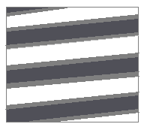

Figure 1: Artefact obtained at position 'a'

1. When there is a RF spike in the position marked ‘b’, one would see narrow, thin artefacts in the approximated direction shown below. This direction corresponds to the direction from which the spike at ‘b’ travels from the centre of K-space. Also, the farther you are from the centre of K-space, the thinner the artefacts are, hence we see thin artefacts in this case with the brain image having very poor contrast but fine edge definitions.

This artefact differs from that at position ‘a’ because it is further away from the centre of K-space making it to have thinner and more frequent bands of stripes. Also, both of them have different directions traveling from the centre which explains the different steepness of their stripes. Lastly, the brain image at artefact ‘b’ will have a very poor contrast as compared to artefact ‘a’, again due to their positions from the centre of K-space.

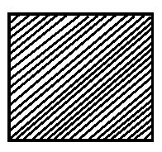

Figure 2: Artefact obtained at position 'b'

## Question 5:

When the RF pulse is applied at 90o, the K-space plot moves from the origin to the most negative KX and KY value. It then shifts the KY value by 180 o (i.e. in the positive KY direction) which is then followed by a 180 o shift of the KX value (i.e. in the positive KX direction) to obtain our first point in the K-space. Each value of Gx is repeated for all possible values of Gy and we get the following initial K-space points as shown below:

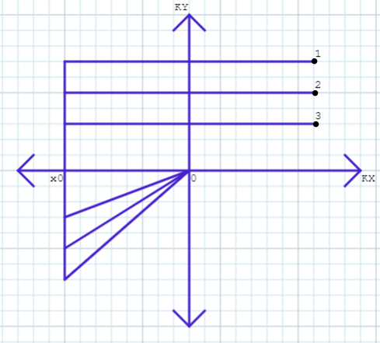

From each Gx value, we are able to obtain a line in the K-space as shown below:

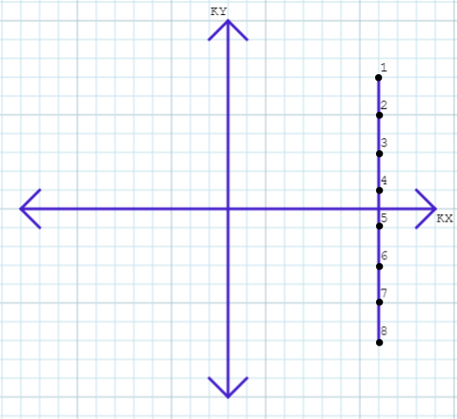

We now move our Gx value to the right (i.e. from x0 to x1) and repeat the above mentioned procedure to obtain another set of points forming a new column of lines in the K-space.

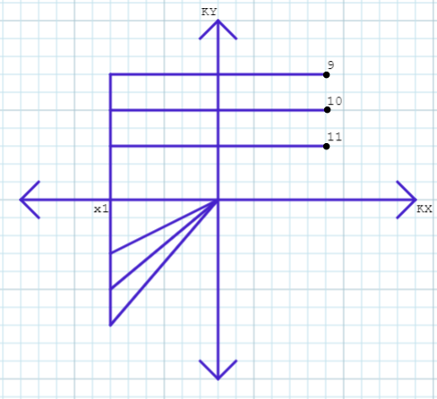

Finally, after sweeping through all possible Gx values, we obtain multiple columns of lines covering the entire K-space. The plot below just covers a few of these lines helping to indicate the pattern of the K-space filling.

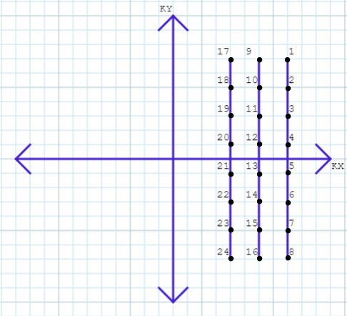

## Question 6:

1. Total acquisition time:
2. For Sequence One:

This is a 3D sequence.

t1 = (Phase resolution * TR * Average) / acceleration factor

t1 = (192 * 2300ms * 1) / 2 = 220.8 s

**t1 = 3.68 minutes**

1. For Sequence Two:

This is a 2D sequence.

t2 = (Measurements + Dummy scan) * TR

t2 = (142 + 3) * 2000ms = 290 s

**t2 = 4.83 minutes**

b. Voxel Size:

1. For Sequence One:

Voxel_Size1 = (FOV_x / Matrix_x) * (FOV_y / Matrix_y) * slice thickness

Voxel_Size1 = (220mm / 256) * (220mm / 192) * 1.2mm

**Voxel_Size1 = 1.182 mm3**

1. For Sequence Two:

Voxel_Size2 = (FOV_x / Matrix_x) * (FOV_y / Matrix_y) * slice thickness

Voxel_Size2 = (220mm / 64) * (220mm / 64) * 4 mm

**Voxel_Size2 = 47.27 mm3**

c. Structural or Functional Image?

1. For Sequence One:

This sequence has only made 1 measurement under the contrast section and has a high resolution of 192 X 256 which indicates that this is a **Structural Image.**

1. For Sequence Two:

This sequence has made 142 measurements under the contrast section and has a low resolution of just 64 X 64 which indicates that this is a **Functional Image.**

## Question 7:

BOLD response is the ‘Blood Oxygenation Level Dependent’ contrast which measures the ratio of oxygenated to deoxygenated haemoglobin in the blood. It leverages the fact that haemoglobin exists in two different states namely Oxyhaemoglobin (which is diamagnetic) and Deoxyhaemoglobin (which is paramagnetic) and it thus measures the difference in the relaxation parameter, T2* between oxygenated and deoxygenated haemoglobin.

The BOLD mechanism:

When at rest, there is normal balanced blood flow and a normal T2*-weighted signal. But when neurons get fired to perform a task, the blood flow in that area increases, resulting in a decreased fraction of Deoxyhaemoglobin, an increase in the CBV and an increase of the T2* relaxation time. This instantenous activity of the neurons, trigger a change in the MR signal which is known as the *Haemodynamic response function.* This response has an initial dip, followed by the signal reaching its peak in 4-6 seconds with a signal change of 0.1% to 5%, then decreases again below baseline level before returning back to baseline in about 30 seconds after the stimulus onset. This response in general is delayed and quite slow with variable response shapes across regions. BOLD response is usually expressed as a percentage signal change with respect to the baseline.

Thus, the fundamental mechanism of the BOLD response is the decreased fraction of deoxyhaemoglobin and the increase of the T2* relaxation time which results in an increase of the BOLD response.

## Question 8:

1. The diagram shows the ‘anode heel effect.’ This refers to the variation of the intensity of X-rays emitted by the anode depending on the direction of emission along the anode-cathode axis. This heel effect may impact the contrast of the x-ray image due to the differences in beam intensity along the x-ray field. Ways to offset the anode heel effect can be by either having a larger source to image distance [SID], a smaller field size or an increase in the anode angle. Another simpler way to offset this can be by placing the high intensity cathode portion of the beam over the most dense part of the patient and the low intensity anode portion of the beam over the least dense part.
2. Filtered back projection is a theorem which corrects back projection by providing a smoothing effect using a high pass filter and recovering the original function. Once we have the back projection of the Radon transform of the attenuation-coefficient function, we fourier transform this and pass it through a high pass filter using an absolute value function, ISI which is then followed by an inverse fourier transform of this product to obtain the filtered back projection.

i.e. 𝑓(𝑥,𝑦)= 0.5B{ F-1[ ∣𝑆∣ F(R𝑓)(𝑆,𝜃)] }(𝑥,𝑦)

|  |  |
| --- | --- |
| **PET SIGNAL** | **CT SIGNAL** |
| i. Uses positrons (radioactive tracers) | i. Uses X-rays |
| ii. Requires the positrons to be injected | ii. Non-invasive |
| iii. Results are three dimensional (3D image) | iii. Results are two dimensional (2D image) |
| iv. Relatively slow imaging compared to CT Scans | iv. Fast imaging |
| v. High energy signals | v. Relatively low energy signals than PET Scans |
| vi. Shows the biological processes within the body | vi. Shows bone structures and soft tissues |

1. False. Ultrasound gel is important for clinical ultrasound scanning as it is used to eliminate air spaces between the probe and the skin by acting as a connector, allowing to obtain clear images of the interested organ. Images obtained without using the gel would be impossible to study.